J17A. KITCH & CO. REAL PHOTO SERIES [date unknown]

Ph George B.D. Kitch
Pu Kitch & Co., Katoomba, also known as Eclipse Photo Co.
F Real photo cards, with view occupying part of card and remaining space in black, white or sepia. Title superimposed on view.

J17A.1 Nellie's Grotto H Empire
J17A.2 [Caves House] Caves, Jenolan V Empire
J17A.3 [Caves House] Caves, Jenolan H ML-2
J17A.4 The Mystery. Imp. C. V Empire
J17A.4A The Mystery. Imp. C. V ML-2
J17A.4AB The Mystery. Imp. C. V (Different view) ML-2
J17A.5 "Shawls" Imp. R. V Empire
J17A.6 [Jenolan Caves - Grotto] V ML-2
J17A.7 Gem of the West H ML-2
J17A.8 "Carrington" Cave H ML-2
38A.9 Lot's Wife, Imp. C. V ML-2
J17A.10 Broken Column. Exhibtn. Cave V Empire
J17A.11 [Gem of the West] V Empire
J17A.12 [Jenolan Caves - Column] V Empire

J17B KITCH & CO. PHOTOGRAVURE SERIES [n.l. 1905]

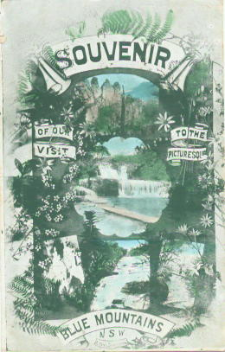
Ph George B.D. Kitch
Pu Kitch & Co., Katoomba, also known as Eclipse Photo Co.
F Photogravure card in sepia or coloured with several small views within ornate floral design.

J17B.1 Souvenir/of our/visit/to the/ /picturesque/Blue Mountains/N.S.W. V (Burke in Stanbury & Bushell 1985, pp. 96-7, dates this card as 1907 and identifies the views as including the Three Sisters, the Federal Pass and 'a minaret' from Jenolan ; two waterfalls remain unidentified).
[pm.9 Apr.1907]
J17B.2 As above, but coloured [pm.25 Mar.1905]

